July 18, 2021

GENERAL ANNOUNCEMENTS

This Week: 9:30 a.m. Reading Service, 6:30 p.m. Catechism Reading Service. Scripture reading following morning service.

Next Week: 9:30 a.m. Reading Service, 6:30 p.m. Catechism Reading Service. Scripture reading following morning service.

-All the Lord willing-

Offerings Today: 1st General Fund Next week: 1st General Fund
2nd Disaster Relief 2nd Theological School

We Remember in Prayer:
-Our widows, widowers and lonely ones, the unborn, prodigal sons and daughters, those undergoing treatments, and all those with hidden crosses.

MEDITATION

“Not unto us, O Lord, not unto us, but unto Thy name give glory, for Thy mercy, and for Thy truth’s sake” (Psalm 115:1).

They who are not sensible of their misery cannot truly look to God for mercy, for it is the very notion of divine mercy, that it is the goodness and grace of God to the miserable. Without misery in the object, there can be no exercise of mercy. To suppose mercy without supposing misery, or pity without calamity, is a contradiction: therefore, men cannot look upon themselves as proper objects of mercy unless they first know themselves to be miserable; and so, unless this be the case, it is impossible that they should come to God for mercy. They must be sensible that they are the children of wrath—that the law is against them and they are exposed to the curse of it; that the wrath of God abideth on them; and that He is angry with them every day while they are under the guilt of sin. They must be sensible that it is a very dreadful thing to be the object of the wrath of God; that it is a very awful thing to have Him for their enemy; and that they cannot bear His wrath. They must be sensible that the guilt of sin makes them miserable creatures, whatever temporal enjoyments they have; that they can be no other than miserable, undone creatures, so long as God is angry with them; that they are without strength and must perish, and that eternally, unless God help them. They must see that their case is utterly desperate for anything that anyone else can do for them; that they hang over the pit of eternal misery; and that they must necessarily drop into it, if God have not mercy on them.
They must be sensible that they are not worthy that God should have mercy on them. They who truly come to God for mercy, come as beggars, and not as creditors: they come for mere mercy, for sovereign grace, and not for anything that is due. Therefore, they must see that the misery under which they are exposed is justly threatened against them; and that they have deserved that God should be their enemy and should continue to be their enemy. They must be sensible that it would be just with God to do as He hath threatened in His holy law, viz. make them the objects of His wrath and curse in hell to all eternity. They who come to God for mercy in a right manner are not disposed to find fault with His severity; but they come in a sense of their own utter unworthiness, as with ropes about their necks, and lying in the dust at the foot of mercy.
From “Great Guilt No Obstacle to the Pardon of the Returning Sinner” in The Works of Jonathan Edwards, Volume 2, p.111

The Fear of the Lord

The fear of the Lord our days will prolong,
In trouble afford a confidence strong,
Will keep us from sinning, will prosper our ways,
And is the beginning of wisdom and grace.

The fear of the Lord is soundness and health;
A treasure well stored with heavenly wealth;
A fence against evil, by which we resist
World, flesh, and the devil, and imitate Christ.

The fear of the Lord is lowly and meek;
The happy reward of all that Him seek;
They only that fear Him the truth can discern,
For, living so near Him, His secrets they learn.

The fear of the Lord confirms a good hope;
By this are restored the senses that droop;
The deeper it reaches, the more the soul thrives;
It gives what it teaches, and guards what it gives.

The fear of the Lord forbids us to yield;
It sharpens our sword and strengthens our shield.
Then cry we to heaven, with one loud accord,
That to us be given the fear of the Lord.

~ Joseph Hart

NOTES

All who would like to stand for the 3rd song are welcome to.

Consistory
Elders: Mr. Rick Rozeboom, Mr. Craig Timmer
Mr. Norm DeWit, Treasurer, Mr. Derek Kattenberg, Clerk
Contacts
Moderator: Rev. Hofman
Bulletin announcements: Mr. Craig Timmer craigtimmer@ymail.com
Sermon recordings: Mr. Ryan Rozeboom
Website: nrcsf.com

Netherlands Reformed
Congregation
Sioux Falls, SD

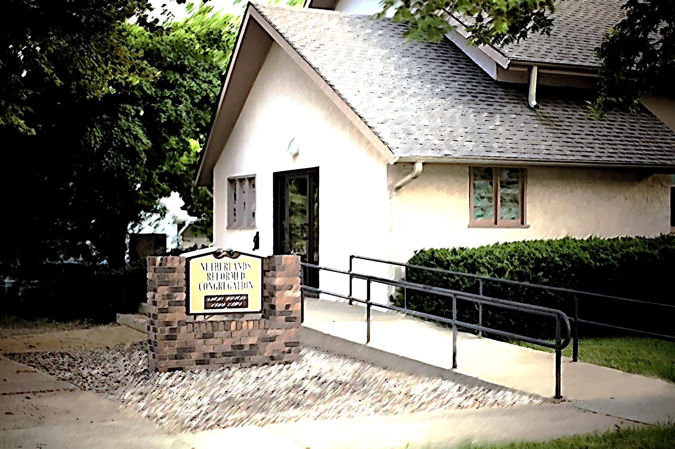
Exalt the LORD our God, and worship at his holy hill; for the LORD our God is holy.
Psalm 99:9

Church Times: 9:30 a.m. and 2:30 or 6:30 p.m.

