March 27th, 2022

Schedule of Events:

This Week: 9:30 AM Reading Service, Classes Following
6:30 PM Reading Service

Next Week: 9:30 AM Reading Service, Classes Following
6:30 PM Reading Service

Tuesday: March 29th, Baby shower for Ashley VanBeek, 7:00 PM at church, all ladies welcome to attend.

Advanced Notice: Classis Midwest is scheduled for April 6th in Covell NRC.

-All the Lord willing-

Announcements:

Offerings: 1st offering: General Fund
2nd offering Today: Hudson Taylor

2nd offering next week: School Fund

Remember in Prayer:

- Our widows, widowers and lonely ones, the unborn, prodigal sons and daughters, those undergoing treatments, and all those with hidden crosses. (“He will regard the prayer of the destitute, and not despise their prayer.” Psalms 102:17)

Meditation:
For 2000 years God appears to have been silent. It is true that during this time He has been at work in the lives of multitudes, bringing them back to Himself through the Lord Jesus Christ, regenerating them by the power of the Holy Spirit and giving them new experiences, desires, hopes, and ambitions. But His operations have been largely hidden. For twenty centuries God has not given this world any outward manifestation of His presence and power such as human sense can see or feel. He has, as it were, withdrawn Himself.
And why is God silent now? In giving His Son He did all that could be done for the salvation of men and women. In the gospel, He has spoken His last word of mercy, and the day of wrath has not yet come. He who is to come as Judge is now sitting on the throne as Saviour. The great amnesty is still in force. The day of grace still runs its course.
But there is a day coming when the world will have to answer for how it treated the Son of God. And you will have to answer the question: “What have you done with Christ?”
It is of no use for you to say, “I’ll be neutral,” for the Lord Jesus Christ says, He that is not with Me is against Me. There is no middle ground: Christ, or Self? Christ, or the world? Which have you chosen?
What will you do with Jesus?
Neutral you cannot be;
Someday your heart will be asking,
“What will He do with me?”
I tried the broken cisterns, Lord,
But, ah! the waters failed!
E’en as I stooped to drink they fled
And mocked me as I wailed.
Now none but Christ can satisfy,
None other name for me!
There’s love, and life, and lasting joy,
Lord Jesus found in Thee!

Ye know not what hour
[the] Lord doth come.
Therefore be ye also ready:
for in such an hour as
ye think not
the Son of man cometh.
Matt 24:42-44

Notes:

All who would like to stand for the 3rd song are welcome to.

Consistory
Elders: Mr. Rick Rozeboom, President
Deacons: Mr. Norm DeWit, Treasurer, Mr. Derek Kattenberg, Clerk
Contacts
Moderator: Rev. Hofman
Bulletin announcements: Mr. Derek Kattenberg nrcsfsd@gmail.com
Sermon recordings: Mr. Ryan Rozeboom
Website: nrcsf.com

Netherlands Reformed
Congregation
Sioux Falls, SD

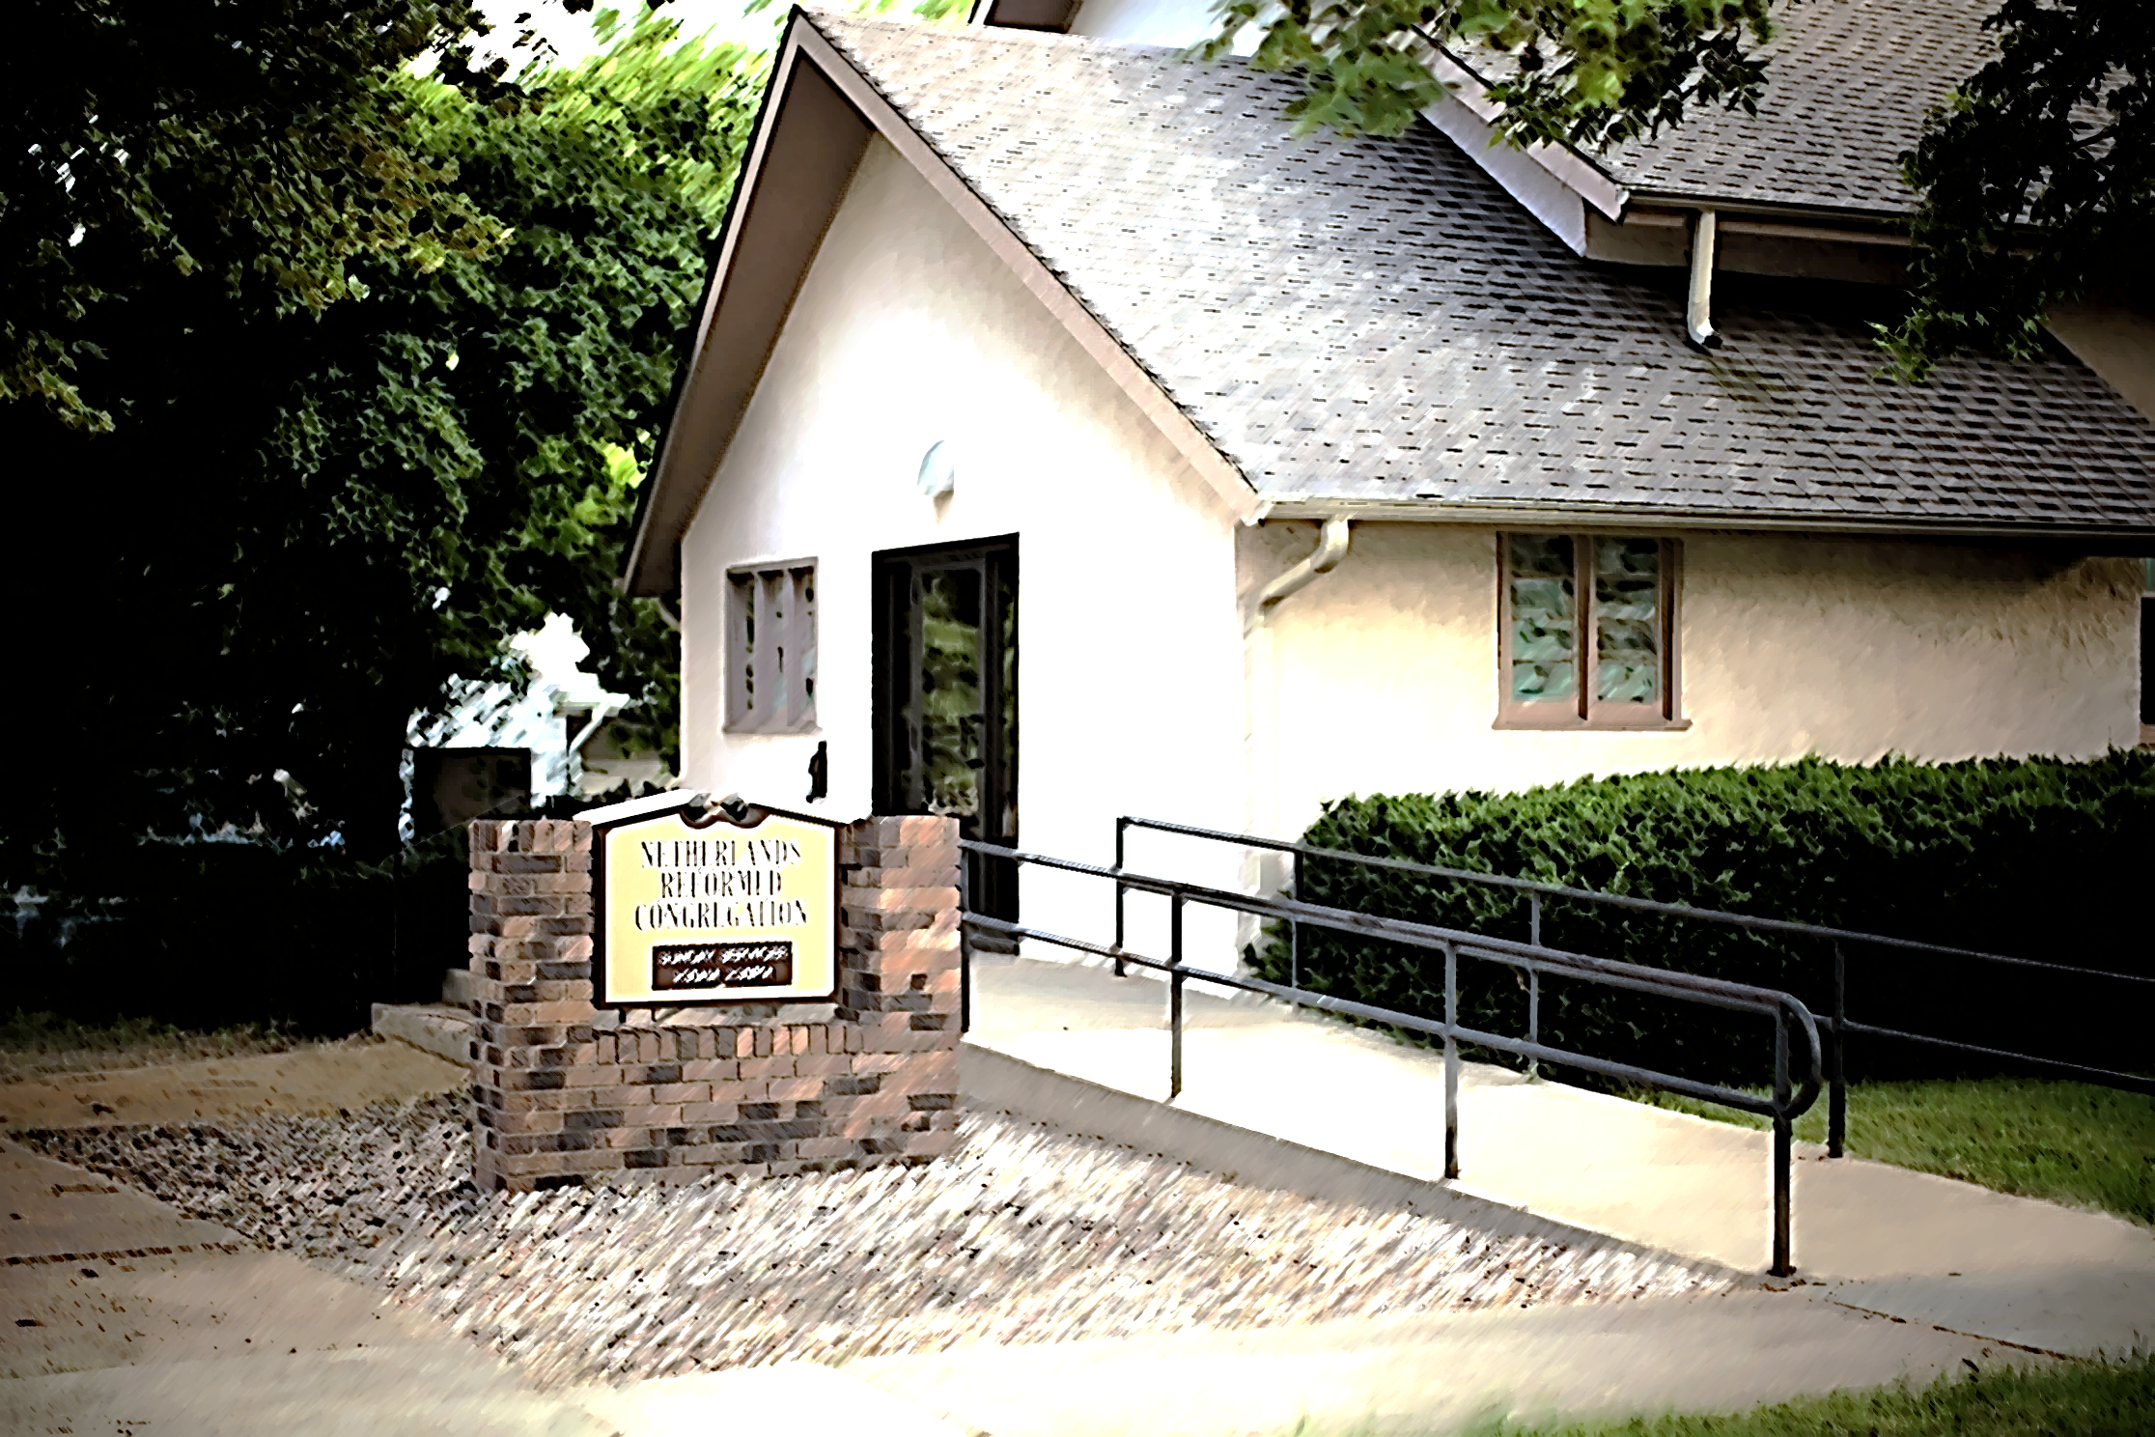

O give thanks unto the LORD; call upon his name: Make known his deeds among the people.
Psalm 105:1

Church Times: 9:30 a.m. and 2:30 or 6:30 p.m.

